Given the provided data, what are three conclusions we can draw about Kickstarter campaigns?

1. “Theater” is the category that has more kickstart campaigns, while the subcategory with more campaigns is “plays”.
2. Without considering live campaigns, I can conclude that it is not good idea to look for funds in December (only 44.05% were successful).
3. Without considering live campaigns, I can conclude that the most successful campaigns were in the music category with 79.41% successful rate.

What are some limitations of this dataset?

1. We do not now who created the campaign, maybe it was by someone relative famous which help them to bring more backers.
2. Even though we have the campaigns in category and subcategories, it is important to be see in more detailed the campaigns that were successful with a percent funded above 200% as they could have more in common than the categories/staff pick/spotlight. For example, the successfulness could be due to specific trend, and not due to the characteristics mentioned before.

What are some other possible tables and/or graphs that we could create?

Calculating the %, I can see which are the best (or worst) categories to do a kickstart campaign. E.g. It is not good idea to make a campaign about journalism.

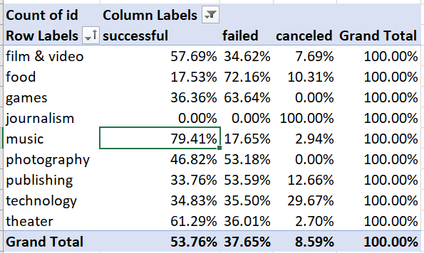

We can also create another table counting backers to underdanst which categories have more backers. Technology is by far the category with more backers:

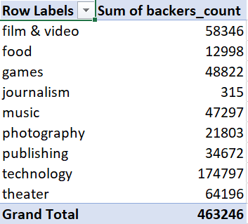

We can also see graphically what percentage was funder by category:

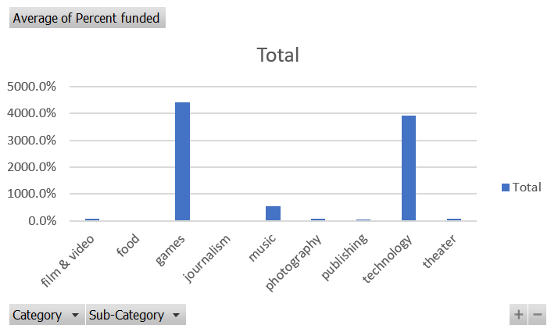

Or see on a table the percentage funded by subcategory :

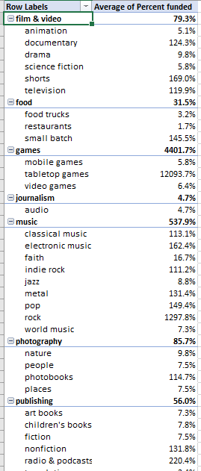

Also get to know how successful are the campaign per country:

